MYSQL QUERIES
RETAIL SHOP ANALYSIS
use project;

select * from sales_data;

describe sales_data;

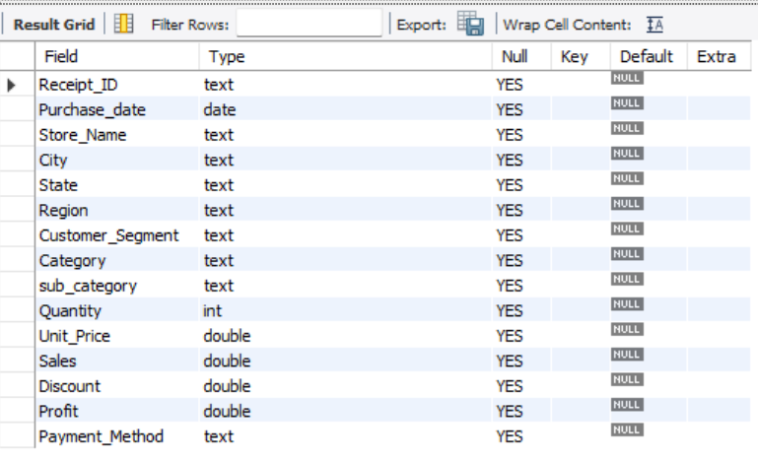
-- change datatype

ALTER TABLE sales_data
MODIFY Purchase_date DATE;

-- Get the total sales
select round(sum(Sales)) as total_sales,round(sum(Profit)) as total_profit from sales_data;
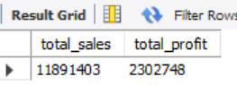

-- total quantity sold
select sum(Quantity) as total_quantity_sold from sales_data
where year(Purchase_date)=2024;
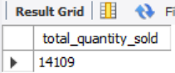

-- total order month wise
select monthname(Purchase_date) ,count(Receipt_ID) as total_order from sales_data
group by monthname(Purchase_date);
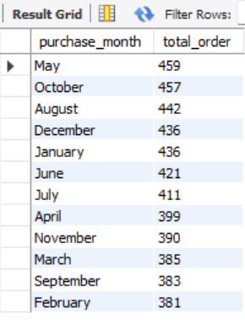

-- total profit
select round(sum(Profit)) as total_profit from sales_data;
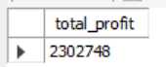

-- top store by sales and profit

select Store_Name,round(sum(sales)) as total_sales,round(sum(Profit)) as total_profit
from sales_data
group by Store_name
order by total_sales desc;
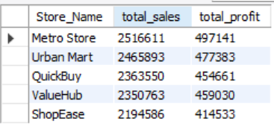

-- most profitble product category and region
-- Category
select Category,round(sum(Profit)) as total_profit
from sales_data
group by Category
order by total_profit desc;
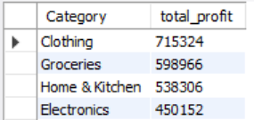

-- Region
select Region ,round(sum(Profit)) as total_profit from sales_data
group by Region
order by total_profit desc ;
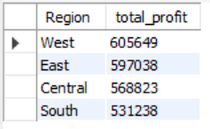

-- is discount effect profit

select Discount ,sum(profit) from sales_data
group by Discount
order by Discount asc;
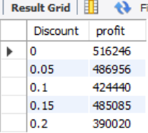

-- 5 most and least profitable sub category
-- most profitable sub-category
select sub_category , round(sum(profit)) as total_profit
from sales_data
group by sub_category
order by total_profit desc
limit 5;
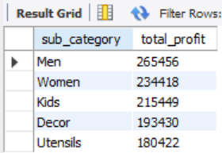

-- most least profitable sub-category
select sub_category , round(sum(profit)) as total_profit
from sales_data
group by sub_category
order by total_profit asc
limit 5;
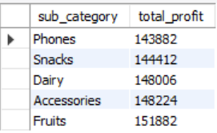

-- above avg and below avg sales
select monthname(Purchase_date) as purchase_month,round(sum(sales)) as total_sales,
case
when sum(sales) > (select avg(month_total) from (select sum(sales) as month_total from sales_data
group by month(Purchase_date)) as monthly_avg) then 'above average'
when sum(sales) < (select avg(month_total) from (select sum(sales) as month_total from sales_data
group by month(Purchase_date)) as monthly_avg) then 'below average'
else 'equal'
end as sales_status
from sales_data
group by month(Purchase_date), monthname(Purchase_date)
order by month(Purchase_date);
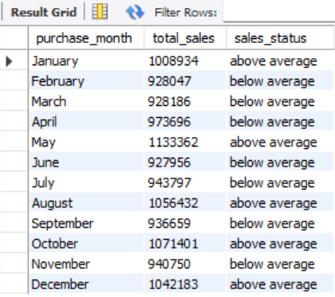

-- most preffered payment mode
select Payment_Method ,count(*) as customers from sales_data
group by Payment_Method
order by customers desc;
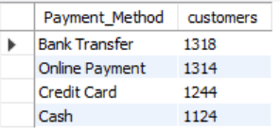

-- lag and lead values for profit in each sub_category

select Category, sub_category, sales, Profit ,
lag(Profit) over(partition by sub_category order by profit ) as previous_profit,
lead(Profit) over(partition by sub_category order by profit ) as next_profit
from sales_data ;

-- Customer Segment performance within each Region
With segment_performance as (
Select Region, Customer_Segment,
round(sum(Sales)) as total_sales,
round(avg(Profit)) as avg_profit
from sales_data
group by Region, Customer_Segment
)
select *,
rank() over(partition by Region order by total_sales desc) as sales_rank,
rank() over (partition by Region order by avg_profit desc) as profit_rank
from segment_performance ;
